Palm Sunday 2021

“Be Careful How You Vote”

Mark 11:1-18

Inauguration Day is one of the great celebrations in our culture. Every four years a President of the United States takes the oath of office before hundreds of thousands on hand and millions on television. It marks a time of change, a time of hope, a time of new possibilities as a new president outlines how he plans to fulfill his campaign promises.
I had the privilege of attending the inauguration of George H. W. Bush in 1989. In fact, there is a picture of me at the event.

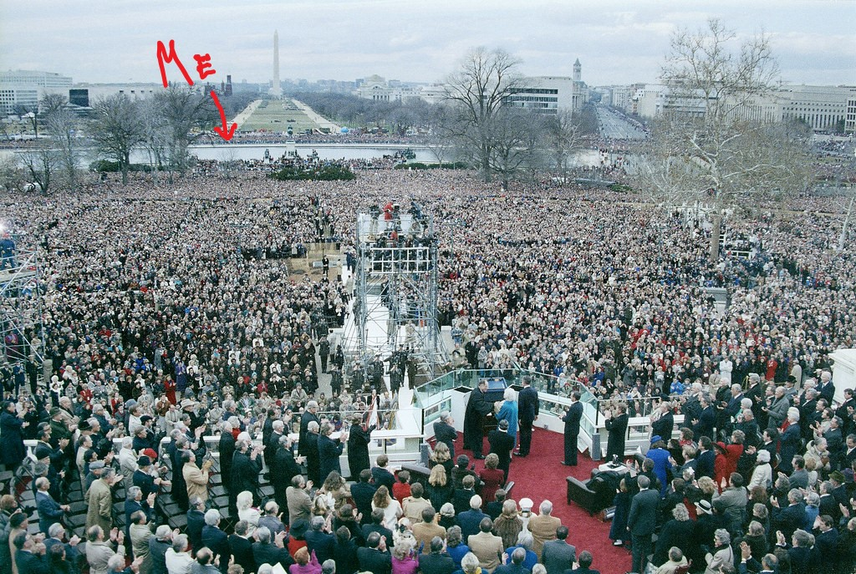

Yes, I was too far away to see or hear anything that was going on, but I was there!
Inauguration Day is, by its very definition, a time of new beginning. A new leader brings in a new vision and agenda. Once the oath of office is taken and the inaugural address given, a parade is held as the new chief executive rides (or walks) down the street as hundreds of thousands cheer. It is a grand spectacle, indeed.
The opening days and weeks of the new administration is sometimes called the “honeymoon” period, as the joyous optimism of the inauguration spills over. How long that “honeymoon” lasts, however, depends on what the new president does in those first weeks or months. For some, it doesn’t last long at all, and the cries of the critics arise from both politicians and the press. Even some of the new president’s ardent supporters may begin to wonder if they cast their vote for the right candidate.
I bring this up not as a commentary on our current political situation, but to introduce an event in the life of Jesus that we celebrate today. We call it Palm Sunday or the Triumphal Entry. All four gospels record this event and it sets the stage for the end of Jesus’ earthly life and ministry, culminating with His arrest and death on Good Friday.
The details of this day are probably familiar to most of you. Frankly Palm Sunday is a challenge for preachers who must try to come up with something new and fresh every year about a subject most of the audience knows a great deal. So this morning I invite you to turn to Mark chapter eleven as we consider this pivotal episode in the life of Jesus under the title, “Be Careful How You Vote.”

An Enthusiastic Call for Change
We begin with an enthusiastic call for change, recorded in Mark 11:1-11,

As they approached Jerusalem and came to Bethphage and Bethany at the Mount of Olives, Jesus sent two of his disciples, saying to them, “Go to the village ahead of you, and just as you enter it, you will find a colt tied there, which no one has ever ridden. Untie it and bring it here. If anyone asks you, ‘Why are you doing this?’ tell him, ‘The Lord needs it and will send it back here shortly.’ ”
They went and found a colt outside in the street, tied at a doorway. As they untied it, some people standing there asked, “What are you doing, untying that colt?” They answered as Jesus had told them to, and the people let them go. When they brought the colt to Jesus and threw their cloaks over it, he sat on it. Many people spread their cloaks on the road, while others spread branches they had cut in the fields. Those who went ahead and those who followed shouted,
“Hosanna!”
“Blessed is he who comes in the name of the Lord!”
“Blessed is the coming kingdom of our father David!”
“Hosanna in the highest!”
Jesus entered Jerusalem and went to the temple. He looked around at everything, but since it was already late, he went out to Bethany with the Twelve.

From the beginning of the chapter we become aware that nothing we are about to read happens by accident or change. Jesus very deliberately plans His entrance into the city of Jerusalem, right down to the last detail. He instructs two of His disciples to go ahead of them and get a donkey colt, one that had never been ridden. They go and find everything exactly as He had instructed.
Jesus chose to ride a colt because this trip down the Mount of Olives, across the Kidron Valley, and into Jerusalem would mark a change in His relationship with the religious and political authorities ruling Judea. He planned to enter Jerusalem as their King, but not the kind of king they anticipated. He would not ride into the city in a show of force like a warrior king. Instead of riding a warhorse, Jesus sat atop a symbol of peace, a donkey. This “Triumphal Entry” looked nothing like the Roman triumph, the lavish parade celebrating a victorious general returning home.
Many patriotic Jews from the crowd of pilgrims eagerly joined the procession that proclaimed Jesus as the Son of David who had come in the name of the Lord. The visitors from Galilee were most prominent in the procession, along with the people who had witnessed the raising of Lazarus from the dead.
As Jesus rode into the city, they lined the road with cloaks and leafy branches. The spreading of garments represents royal homage, as in 2 Kings 9:13. Branches were also waved in homage to rulers, according to the apocryphal books of Maccabees. John mentions that these were palm branches, which apparently came from Jericho, since they are not native to Jerusalem. But the palm branch was very significant at that time. It was the national emblem of an independent Palestine—like a Jewish flag.
The crowd shouted “Hosanna!” a transliteration from a Hebrew expression meaning “Oh, save us now!” They also quoted from Psalm 118:26, a familiar messianic psalm and one of the six “ascent” psalms sung in thanksgiving to God during Passover. This particular song was sung in remembrance of the exodus and in anticipation of the future restoration of Israel in a new exodus under a victorious Davidic king. These words were fresh in everyone’s minds; hopes for the restoration of the Davidic kingdom also ran high at this time of year.
Many scholars and preachers claim that Jesus was truly offering Himself as the Jewish Messiah, the king who would fulfill the many Old Testament prophecies, and that if the Jews had accepted Him as such, He would have established Himself on the throne of David and kicked out the Romans. This is simply not the case. The Gospels record other instances when the people wanted to make Jesus their King, and He escaped from them. Later this same week Jesus would tell Pilate, “My kingdom is not of this world.” He did not come to be crowned as King the first time; He came to “give His life as a ransom for many,” according to Mark 10:45. It would be wrong to think that Jesus rode in as king, as though He were staging a demonstration to make clear His messianic claims. Jesus came in peace, offering these wayward people an opportunity to humble themselves, repent of their sins, receive His grace, and experience genuine liberty.
Certainly some in the crowd welcomed Jesus as their Messianic deliverer, little suspecting that his way of being Messiah is radically different from what they envisage. I am reminded of the phrase in the classic comedy film The Princess Bride, “You keep using that word, [but] I do not think it means what you think it means.”
Before I move on, I do want to clear up one common misconception about Palm Sunday. You sometimes hear it said that the same people who cried “Hosanna!” on Palm Sunday ended up crying “Crucify Him!” on Good Friday, but this is not true.
The crowd that wanted Him crucified came predominantly from Judea and Jerusalem—those supporting the Jewish leadership—whereas the Galilean Jews were sympathetic with Jesus and His ministry.
Yet as we will see, some of Jesus’ enthusiastic supporters may have questioned their choice as the events of the following days unfolded.

An Energetic Challenge to the Common
Continuing in Mark 11, we see an energetic challenge to the common in a couple of instances, the first described in verses 12-14,

The next day as they were leaving Bethany, Jesus was hungry. Seeing in the distance a fig tree in leaf, he went to find out if it had any fruit. When he reached it, he found nothing but leaves, because it was not the season for figs. Then he said to the tree, “May no one ever eat fruit from you again.” And his disciples heard him say it.

This is a puzzling passage for Bible scholars and students alike. Jesus seems to act so impulsively and destructively here—very out of character for the One described so far. Yet, as one commentator writes, “Unless we realize that this whole event was an acted parable we shall be puzzled by all sorts of irrelevant questions.”
Jesus and His disciples left Bethany to walk down the Mount of Olives, across the Kidron Valley, and up the ravine to enter the temple complex. On the way, the group passed a fig tree “in leaf,” a phrase describing what people in the ancient Near East would have understood to be the time when fig trees produce small, edible buds. These buds eventually fall off and figs grow in their place. If no buds appear, however, then the plant is barren; it will produce no fruit. Every farmer knows that a fruit tree that bears no fruit is completely worthless. It takes up valuable land and resources for no good purpose, which means it’s better used for firewood. Therefore, Jesus pronounced judgment on the tree in verse 14, saying, “May no one ever eat fruit from you again!” Because everyone would know that it was “not yet the season for [real] figs,” Jesus is making a point about trees that only pretend to have good fruit.
The tree gave outward promise of fruit but nothing more: so its punishment was to remain eternally barren. In a sense, this withering of the tree was only a perpetuation of its present fruitless condition. The fig tree and the vine are two time-honored symbols of Israel, to whom God’s Son had now come, looking for fruit and finding none, though there was outward religious profession in plenty. Israel had failed to be fruitful for God. Like the fig tree our Lord cursed, Israel had “nothing but leaves.” What Jesus is doing is pronouncing on the already sealed fate of the nation. This shocked His disciples.
If that were not shocking enough, we read on what happened when Jesus arrived at the Temple in verses 15-17,

On reaching Jerusalem, Jesus entered the temple area and began driving out those who were buying and selling there. He overturned the tables of the money changers and the benches of those selling doves, and would not allow anyone to carry merchandise through the temple courts. And as he taught them, he said, “Is it not written: “‘My house will be called a house of prayer for all nations’? But you have made it ‘a den of robbers.’”

Jesus challenged a long-standing practice sanctioned by the chief priests, a moneymaking scheme that raked in fortunes each festival season. The chief priests refused to accept any currency except shekels minted in Israel. Moneychangers within the temple precincts gladly exchanged any currency for Jewish shekels at an inflated rate and then pocketed the difference.
Jesus angrily confronted the corrupt merchants and moneychangers, overturned their tables, and refused to allow anyone to conduct any further business within the temple precincts. To accomplish this, Jesus had to become a physically imposing figure, someone perceived as dangerous and therefore not to be defied. While taking command, Jesus quoted from Isaiah and Jeremiah: “‘My house will be called a house of prayer for all the peoples.’ The Lord God, who gathers the dispersed of Israel, declares, ‘Yet others I will gather to them, to those already gathered’” (Isa. 56:7-8); “Has this house, which is called by My name, become a den of robbers in your sight? Behold, I, even I, have seen it,” declares the Lord” (Jer. 7:11)
Jesus had cleansed the temple during His first Passover visit, as recorded in John 2, but the results had been temporary. It was not long before the religious leaders permitted the moneychangers and the merchants to return. The priests received their share of the profits, and, after all, these services were a convenience to the Jews who traveled to Jerusalem to worship. The money rates were always changing, so the men who exchanged foreign currency were doing the visitors a favor, even though the merchants were making a generous profit. It was easy for them to rationalize the whole enterprise. But Jesus claimed that turning the Gentile court into a marketplace meant it could no longer properly be the place of prayer for the nations that God had originally intended. So He kicked them out.
Our Lord’s condemning of the tree and cleansing of the temple were both symbolic acts that illustrated the sad spiritual condition of the nation of Israel. In spite of its many privileges and opportunities, Israel was outwardly fruitless (the tree) and inwardly corrupt (the temple). It was unusual for Jesus to act in judgment, yet there comes a time when this is the only thing God can do.
What does this mean for us? When Jesus comes to town, He often challenges the things that are most dear to us. We may enthusiastically call for change, but when Jesus comes and challenges those things we find comfortable, how will we respond?

An Eventual Compunction of the Choice
We see an eventual compunction (or second thoughts) of the choice in verse 18: “The chief priests and the teachers of the law heard this and began looking for a way to kill him, for they feared him, because the whole crowd was amazed at his teaching.”
Knowing the priestly aristocracy, one can easily recognize that they saw in Jesus’ attack on the temple establishment a threat to their own economic and social interests. Their position in relation to both the Romans and their own people depended in large measure on their authority and keeping order in the temple. They regarded Jesus as a dangerous threat to their whole way of life.
They weren’t merely offended; they became sufficiently enraged to seek His destruction. They feared His influence because of the adoring multitudes, they feared the penetrating truth of His message, and they feared His ability to expose their sins. So they thought of ways to kill Him. The Greek word translated “destroy” is particularly violent. It was used in reference to murder or to the devastation caused by a storm. Of course we know that, in the coming days, they were able to successfully get rid of this threat to their status quo by getting the Romans to do their dirty work.
I realize you are probably familiar with this story. So how does this apply today?
I suggest that Jesus is the ultimate candidate for change. And by “change” I am not referring to rearranging the furniture. He wants to make us new creations. His campaign slogan is, “The old is gone; the new has come.” He is the proponent of radical change.
Most people are not that excited about radical change, however. As one old wag put it, “The only person that likes change is a wet baby.” We tend to resist change, especially when it challenges what is familiar and comfortable to us. Let’s face it: most of us like the status quo. We don’t want someone coming in rocking the boat.
Jesus wants to not only rock your boat; He wants to rock your world. He makes statements like, “If anyone comes to me and does not hate his father and mother, his wife and children, his brothers and sisters—yes, even his own life—he cannot be my disciple. And anyone who does not carry his cross and follow me cannot be my disciple” (Luke 14:26-27). Or, “Why do you call me, ‘Lord, Lord,’ and do not do what I say?” (Luke 6:46)
Jesus is not interested in being your eternal fire insurance or your “Get out of Hell free” card. He did not die on the cross to wash your sins away so you could go wallow in them some more. He does not come to put His divine stamp of approval on our status quo.
The crowds on the first Palm Sunday were enthusiastic about the change they saw Jesus bringing. But they looked for Him to change everybody else, not they themselves. Jesus comes to you and says, “I’m here to take over. I’m here to institute lasting change. It won’t always be easy or pleasant, but trust Me, it will be for your good.”
Be careful how you vote. In our country, you can change your mind in four years. But with Jesus, your eternity is at stake. He wants to be your Lord and King.
Can He?

Charles R. Swindoll, Insights on Mark (Carol Stream, IL: Tyndale House Publishers, ©2016).
Warren W. Wiersbe, Be Diligent (Wheaton, IL: Victor Books, ©1987).
Craig S. Keener, The IVP Bible Background Commentary: New Testament (Downers Grove, IL: InterVarsity Press, ©1993).
Kenneth L. Barker, ed., The NIV Study Bible (Grand Rapids, MI: Zondervan, ©1985).
Paul L. Maier, First Easter (San Francisco: Harper & Row Publishers, ©1973), p. 11.
Swindoll, op. cit.
D. A. Carson, “The Gospels and Acts,” in NIV Biblical Theology Study Bible (Grand Rapids, MI: Zondervan, ©2018).
Keener, op. cit.
Ralph P. Martin, Where The Action Is, A Bible Commentary for Laymen (Glendale, CA: Regal Books, ©1977).
Swindoll, op. cit.
Carson, op. cit.
Wiersbe, op. cit.; Maier, op. cit.
R. Alan Cole, Mark: An Introduction and Commentary, Tyndale New Testament Commentaries (Downers Grove, IL: InterVarsity Press, ©1989).
Swindoll, op. cit.
Keener, op. cit.
Cole, op. cit.
Wiersbe, op. cit.
Martin, op. cit.
Swindoll, op. cit.
Wiersbe, op. cit.
Carson, op. cit.
Wiersbe, op. cit.
Keener, op. cit.
Barker, op. cit.
Swindoll, op. cit.

